
LESSON NOTE | DETAILED EXPLANATORY NOTES
GENETICS & MOLECULAR BIOLOGY
SEX LINKAGE, CO-DOMINANCE & INCOMPLETE DOMINANCE
GRADE 12 - BIOLOGY
■ ■ ■

Beyond Simple Dominance
In simple Mendelian inheritance, one allele is completely dominant and hides a recessive one, giving a neat 3:1 ratio. But nature is often more subtle. In this lesson we look at three important exceptions to simple dominance: incomplete dominance (where alleles blend), co-dominance (where both alleles show fully), and sex linkage (where a gene sits on a sex chromosome and so affects males and females differently).
These patterns still follow Mendel's basic rules - alleles separate and recombine - but the phenotypes they produce are different from the usual dominant/recessive result. Understanding them explains real cases such as flower colour, human blood groups, and colour blindness, and is an important part of the Genetics & Molecular Biology strand.
Why This Matters
- Many real traits do not follow simple dominant/recessive patterns.
- They explain blood groups, flower colour and inherited conditions.
- Sex linkage explains why some conditions affect males more often.
- They are essential for genetic counselling and understanding heredity.
Sex Linkage, Co-dominance & Incomplete Dominance
Key Learning Outcomes
By the end of this lesson, students should be able to:
- Explain incomplete dominance and work out its ratios.
- Explain co-dominance using human blood groups.
- Distinguish clearly between incomplete dominance and co-dominance.
- Explain sex linkage and why it affects the sexes differently.
- Use Punnett squares to predict offspring for each pattern.
Incomplete Dominance
In incomplete dominance, neither allele is fully dominant, so the heterozygote shows a blend - an intermediate phenotype. A classic example is flower colour in snapdragons: a red flower (RR) crossed with a white flower (WW) gives offspring that are all pink (RW), a mix of the two. If two pink flowers are then crossed, the offspring appear in a 1 red : 2 pink : 1 white ratio. Notice that the ratio is the same as a normal cross, but now each genotype has its own distinct appearance, because the heterozygote looks different from both parents.
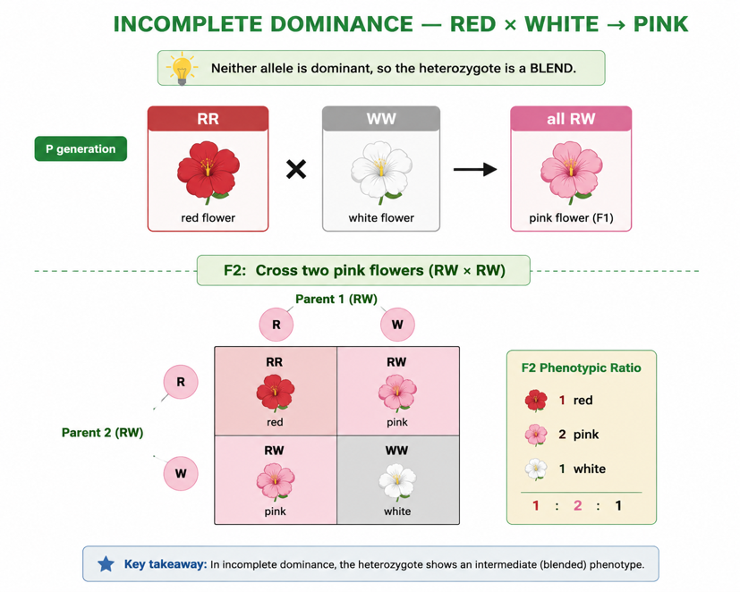
Figure 1: Incomplete dominance - red × white gives pink; crossing two pink gives a 1 red : 2 pink : 1 white ratio.
Terminologies and Concepts
Useful terms for this topic:
- Allele: one version of a gene.
- Homozygous / heterozygous: two identical alleles / two different alleles.
- Incomplete dominance: the heterozygote shows a blend of the two alleles.
- Co-dominance: both alleles are fully expressed in the heterozygote.
- Multiple alleles: a gene with more than two possible alleles (e.g. blood groups).
- Sex chromosomes: the X and Y chromosomes that determine sex (XX = female, XY = male).
- Sex-linked gene: a gene carried on a sex chromosome, usually the X.
- Carrier: a person who has a recessive allele but does not show the trait.
Co-dominance
In co-dominance, both alleles are fully expressed at the same time - neither is hidden and there is no blending. The best example is the ABO blood group system, which has three alleles: Iᴬ, Iᴮ and i. Iᴬ and Iᴮ are co-dominant with each other, while both are dominant over i. A person with IᴬIᴮ has blood group AB and makes both A and B antigens on their red blood cells - a clear sign that both alleles are working together. If a group A parent (Iᴬi) is crossed with a group B parent (Iᴮi), the children can be AB, A, B or O, showing all the combinations.
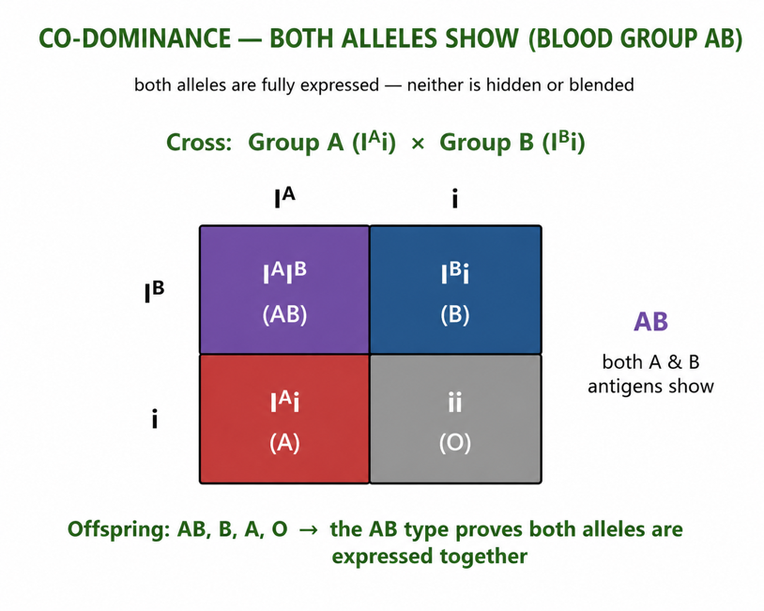
Figure 2: Co-dominance in blood groups - an IᴬIᴮ person is group AB, expressing both A and B antigens fully.
Incomplete Dominance vs Co-dominance
These two are easy to confuse, so the difference is worth stressing. In incomplete dominance, the two alleles mix to make a new, intermediate phenotype (red + white = pink). In co-dominance, the two alleles both appear separately and fully (A + B = AB, not a blend). A helpful memory aid: incomplete dominance blends, co-dominance shows both.
Sex Linkage
A sex-linked gene is carried on a sex chromosome - almost always the X chromosome. Females are XX and males are XY. Because the Y chromosome is small and carries no matching copy of most X genes, a male has only one copy of each X-linked gene, so even a single recessive allele will show in him. A female, with two X chromosomes, can be a carrier - carrying the recessive allele on one X but hidden by a normal allele on the other. This is why X-linked recessive conditions such as red–green colour blindness and haemophilia are much more common in males.
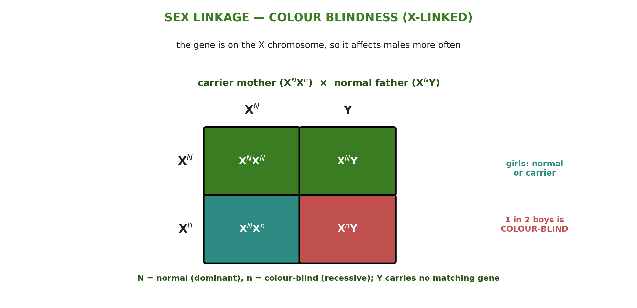
Figure 3: Sex linkage - a carrier mother and normal father can have colour-blind sons but no colour-blind daughters.
Worked Example - A Sex-Linked Cross
Consider colour blindness, where Xᴺ = normal vision (dominant) and Xⁿ = colour-blind (recessive). A carrier mother (XᴺXⁿ) marries a normal father (XᴺY):
XᴺXⁿ × XᴺY → XᴺXᴺ , XᴺXⁿ , XᴺY , XⁿY
The daughters are all normal-sighted (one is a carrier, XᴺXⁿ), but among the sons, half (XⁿY) are colour-blind. So this couple can have colour-blind sons but no colour-blind daughters - the typical pattern of an X-linked recessive trait, where the condition passes from a carrier mother to her sons.
Why This Matters
- Real inheritance - most traits are more complex than simple dominance.
- Blood transfusion - blood-group co-dominance is vital for safe transfusions.
- Health - sex linkage explains conditions like colour blindness and haemophilia.
- Genetic counselling - these patterns help predict inherited conditions in families.
PNG Context Example
These inheritance patterns matter for health in Papua New Guinea. Blood grouping (co-dominance of A and B) is essential for safe blood transfusions in hospitals - for example during childbirth or after accidents - so understanding the ABO system saves lives. Sex-linked conditions such as red–green colour blindness affect more boys than girls, which can matter for tasks that rely on colour, and haemophilia is a serious X-linked bleeding disorder. Understanding carriers and how these traits pass through families supports genetic awareness and counselling, helping families understand the chances of inherited conditions in their children.
References & Related Documents
Source Documents
- Biology Standards-Based Syllabus, Grades 11 & 12 (PNG SBC 2020) - Strand: Genetics & Molecular Biology; Unit on inheritance - investigate patterns of inheritance including incomplete dominance, co-dominance and sex linkage.
- STEM Biology Syllabus - Grade 12. Thema: Genetics; Module: Patterns of Inheritance. Department of Education, PNG.
Further Reading & References
- OpenStax Biology - Extensions of the Laws of Inheritance; Incomplete Dominance, Codominance and Sex Linkage. https://openstax.org/books/biology
- Khan Academy - Variations on Mendelian genetics; sex linkage. https://www.khanacademy.org/science/biology/classical-genetics

